Page 2
2019 eLECTRONIC dONATION fORM
------------------------------------------------------------------------------------------------------------------------------------------------------------------
 | FOR OFFICE USE ONLY: |  |  |  | ENVELOPE/DONOR #: |  |  |  |  | DATE:
 | Effective date of authorization: _____/_____/_____
 | Type of authorization: |  | - New authorization |  |  | - Change donation amount |  |  |  |  |  | - Change donation date
 |  |  | - Change banking information |  |  | - Discontinue electronic donation
 | Last Name |  |  |  |  |  | First Name
 | Address
 | City |  |  |  |  |  |  |  |  |  | State |  |  | Zip
 | Email Address
 | DATE OF FIRST DONATION:  ______/______/______ |  |  | FREQUENCY OF DONATION:  - Weekly – Mondays  - Monthly on the 1st  - Monthly on the 15th |  |  |  | FUNDS:  - General/Operating  - Other________________  Total |  |  |  |  | AMOUNTS:  $_____________  $_____________  $_____________
 | CHECKING / SAVINGS | Please debit my donation from my (check one):  - Savings Account (contact your financial institution for Routing #)  - Checking Account (attach a voided check below)  I want to continue to receive offering envelopes.  Yes_____ No_______ |  |  |  |  |  |  | Routing Number: ___________________________________  Valid Routing # must start with 0, 1, 2, or 3  Account Number: ___________________________________  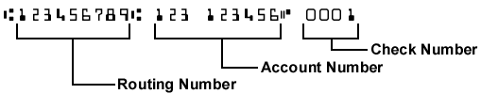
I authorize the above organization to process debit entries to my account. I understand that this authority will remain in effect until I provide reasonable notification to terminate the authorization.

Authorized Signature:_______________________________________________________ Date:________________

If using a checking account, please attach a voided check here.

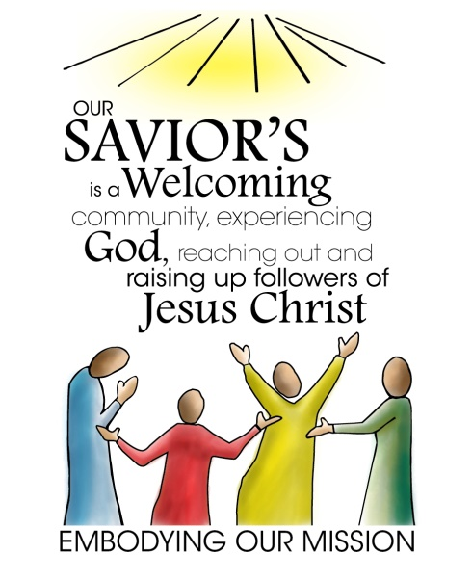

Annual Pledge Form
2019 PLANNED DONATIONS

Yes! I/We want to make a difference in people’s lives. I/We are hopeful and energized about the projects and ministry happening here at Our Savior’s. I/We gratefully thank God for the opportunities ahead. And I/We will help discover God’s future by pledging our support.

-----------------------------------------------------------------------------------------------------

I/We plan to offer $___________ per week / month / year (circle one) to further God’s work through the congregation during calendar year 2019.

Name(s) __________________________________________________________________

Address___________________________________________________________________

Phone _______________________________________
Email _______________________________________

We encourage electronic donations.
If using ACH for your offering, please complete other side.

